


Alpha Analytics
Final Report

Business Context
Hedge funds operate in highly competitive, data-driven markets where the ability to interpret information quickly can provide a decisive edge. A key source of volatility is company earnings announcements, which often trigger sharp price movements and create both opportunity and risk. VP Analytics, a data analytics consultancy serving hedge fund clients, engaged our team - Alpha Analytics - to examine the impact of earnings announcements on the stock price behaviour of three major technology firms: Apple, NVIDIA, and Google. Our central questions were whether pre-earnings patterns can predict post-earnings reactions, how macroeconomic factors interact with these dynamics, and what the implications are for investment strategy.

Project Development Process
Our project followed a structured, iterative workflow designed to reflect how hedge funds typically approach data-driven research around key market events. We began by defining the scope: five years of quarterly earnings announcements for Apple, NVIDIA, and Google. These firms were selected due to their size, influence, and frequent earnings events, which provided a robust dataset for testing event-driven trading strategies.

Data Collection
We gathered three categories of data. First, we sourced daily stock price data - including opening, high, low, closing prices, and trading volume - for the three companies, as well as benchmark indices (S&P 500 and NASDAQ). Second, we collected quarterly earnings data from SEC filings and company investor relations reports, focusing on reported versus expected earnings per share (EPS). Finally, we compiled relevant macroeconomic indicators, including GDP growth, CPI inflation, interest rates, and unemployment, from the Federal Reserve Economic Data (FRED). While macro factors were not central to our final findings, including them gave us the flexibility to test whether broader market conditions influenced earnings-related movements, and we see this as a valuable area for future research.

Data Cleaning and Preparation
Before analysis, the datasets required harmonisation. We standardised date formats to ensure alignment across sources, removed duplicates, and adjusted price data for stock splits. We also mapped earnings events precisely to their announcement dates, including “day before” and “day after” windows to capture both pre-positioning and post-announcement effects.

Exploratory Analysis
Our exploratory analysis focused on uncovering patterns in price behaviour around earnings events. We examined daily returns and rolling measures of volatility, identifying spikes in market activity in the days around announcements. We also calculated EPS surprises - both as absolute differences and relative percentages - and compared return distributions for beats versus misses. This highlighted asymmetries: negative surprises often triggered larger and more persistent downward moves than the gains observed after positive surprises. These insights suggested potential opportunities for both momentum and contrarian strategies, while also signalling the importance of risk management.

Event Study Methodology
To quantify these effects systematically, we implemented an event study framework. This approach measures abnormal returns and aggregates them into cumulative abnormal returns (CARs) across specified windows (ten days before to ten days after earnings). This structure allowed us to compare how stocks behaved around beats versus misses, and later to expand our analysis beyond the initial three companies to the top 19 Nasdaq stocks without altering the underlying methodology.

From Analysis to Strategy
The final step of the process was to translate our findings into trading strategies. We focused on three: pre-earnings run-up (buying ahead of likely positive surprises), post-earnings momentum (trading in the direction of the surprise), and contrarian trades (betting on reversals after initial reactions). These strategies were tested on both the initial three-company sample and the expanded Nasdaq-19 dataset to evaluate their consistency and scalability.

Summary
This process - from data collection through cleaning, analysis, and strategy testing - enabled us to build a clear, replicable framework. While macroeconomic factors played only a limited role in the final results, their inclusion lays the groundwork for future research on regime-dependent performance. The modular structure ensures VP Analytics can reuse and expand this framework in future earnings cycles.

Technical Overview of the Code
Our technical approach was guided by the need to balance accuracy, efficiency, and scalability. This section reflects on the rationale behind our chosen tools and techniques, and evaluates how these decisions shaped the quality and scope of our analysis.

Choice of Python as the Primary Environment
We selected Python as our central tool because of its widespread use in quantitative finance and its extensive ecosystem of libraries for data analysis. Unlike spreadsheet-based approaches, Python offered the flexibility to handle large, multi-source datasets and automate repetitive processes. Its modularity allowed us to design functions for event study analysis that could be reapplied to new companies and time periods with minimal modification. This scalability was essential, as our project extended from three firms to the broader Nasdaq universe. To host our workflow, we used Google Colab. This was chosen for its accessibility, cloud-based environment, and seamless integration with Python libraries. Colab allowed the team to collaborate in real time without the need for complex local setups, which was particularly valuable given our distributed working arrangements.

Analytical Techniques
We adopted an event study framework to measure stock market reactions to earnings announcements. This method is a well-established standard in financial research, allowing us to isolate abnormal returns relative to benchmarks such as the S&P 500 and Nasdaq. Alternative techniques, such as regression using machine learning, were considered, but we judged them less suitable given the limited number of earnings events in our initial dataset. By prioritising an event study, we ensured methodological accuracy while maintaining transparency for a hedge fund audience.

Supporting Libraries and Tools

- pandas and NumPy: These provided efficient structures for cleaning, aligning, and transforming time-series data. Their ability to handle millions of rows of stock price observations without significant performance issues was a major strength.
- Matplotlib and Seaborn: These libraries enabled us to translate complex patterns into clear, interpretable visuals. High-contrast charts and simple layouts were prioritised to highlight volatility clusters, distribution shifts, and strategy performance in a way that could inform investment decisions.
- statsmodels: While not used for full regression modelling, this library was valuable for statistical testing, such as calculating t-statistics to assess whether observed returns were statistically significant.

AI Assistance
Another feature of our workflow was the incorporation of AI tools (Claude/ChatGPT) to support development. AI accelerated repetitive coding tasks, such as generating functions for event windows or suggesting alternative ways to merge datasets. This increased efficiency allowed us to expand the project scope within the tight timeframe. However, AI outputs were not always reliable: suggestions sometimes produced errors or inefficient operations. This required careful human oversight, testing, and validation to ensure the code aligned with financial logic and produced trustworthy results.

Benefits and Limitations
Our choices enabled us to deliver a modular, reproducible, and scalable pipeline that can be reapplied by VP Analytics to future earnings cycles. Python’s open-source ecosystem reduced costs and improved transparency, while the event study framework provided credibility by drawing on established financial research methods.
At the same time, there were limitations. Python’s reliance on external libraries meant occasional compatibility issues and dependency management challenges. The event study approach, while robust, is inherently backward-looking and may not fully capture complex interactions such as sentiment effects or intraday trading dynamics. Finally, while AI assistance was valuable, it required active steering and critical judgement to avoid errors.

Summary
Overall, our technical decisions supported a balance of accuracy, clarity, and efficiency. The combination of Python’s ecosystem, a proven event study framework, and selective use of AI tools allowed us to generate actionable insights within a limited timeframe. With further development - such as integrating sentiment analysis or more advanced statistical models - this pipeline could be extended into an even more powerful decision-support tool for hedge funds.

Strategies + Recommendations
Our analysis translated event study results into systematic trading strategies, each tested first on Apple, NVIDIA, and Google before being scaled to the top 19 Nasdaq stocks.

Pre-Earnings Run-up
The most consistent finding was the Pre-Earnings Run-Up strategy, which involves taking long positions in the ten trading days before earnings announcements. In the 3-stock sample (69 trades), this approach delivered an average return of +2.81%, with a 60.9% hit rate and a t-stat of 3.66. Optimising the window to –15 through +1 produced even stronger results (+6.23% average return, 71.0% hit rate, t-stat 5.02), although with higher volatility. Scaling to the Nasdaq-19 sample (435 trades) confirmed the robustness of the signal, yielding +1.51% average return, 57.7% hit rate, and t-stat 4.78. This indicates that run-up effects are systematic and can be exploited at portfolio level.

Post-Earnings Momentum + Contrarian
The Post-Earnings Momentum strategy also generated consistent positive returns. In the 3-stock test, average returns were +1.36% with a modest t-stat of 1.22, but in the Nasdaq-19 expansion (433 events) the average was +1.57% with a much stronger t-stat of 3.71, confirming statistical significance once the cross-section was broadened. By contrast, Contrarian approaches — shorting beats or buying misses — were inconsistent and often negative, with a statistically significant negative t-stat of −2.05 on the Nasdaq-19 sample. These findings suggest that contrarian rules are not suitable for systematic hedge fund deployment.

Pre-Earnings Hold/Cut (Tradable Extension)
Our earlier capstone flagged that filtering pre-earnings entries by EPS surprise lifted returns materially — but that rule relies on information only knowable after the announcement, so it is not tradable in production. We re-implemented the strategy in a look-ahead-free way: enter long at day −10 on every event with no pre-entry filter, then at day 0 (once the surprise is public) decide whether to cut at day 0 or hold through an extended exit window. On the Nasdaq-19 sample (429 events), entering at −10 and using a 5% surprise threshold to decide hold-through-day +5 vs cut-at-day 0 delivered an average return of +2.73% with a 62.2% hit rate and a t-stat of 5.44. Extending the hold window to day +10 for the high-surprise cohort pushed the mean to +3.26% at a t-stat of 5.91. Critically, every entry and exit decision in this variant is made using information that was public at the time of the decision — the surprise becomes our signal for duration, not for selection. This is the strongest and most credible result in the study.

Recommendations
Focus on the Pre-Earnings Hold/Cut variant as the lead strategy, with Pre-Earnings Run-Up and Post-Earnings Momentum as complementary sleeves in a combined portfolio to diversify sources of return and smooth risk. The Hold/Cut variant should be prioritised because it uses the EPS surprise as a legitimate, post-announcement signal for exit duration rather than for entry selection, removing the look-ahead bias that inflated earlier results. The next step is to integrate macro filters to adjust exposure depending on market regimes and to explore model combination approaches — for example, blending run-up, momentum and hold/cut signals with sentiment analysis from earnings calls. This would enhance predictive power and deliver a more robust, hedge fund-ready investment framework.
(Word count: 1,579)

Appendix

Insights - APPL, NVDA, GOOGL
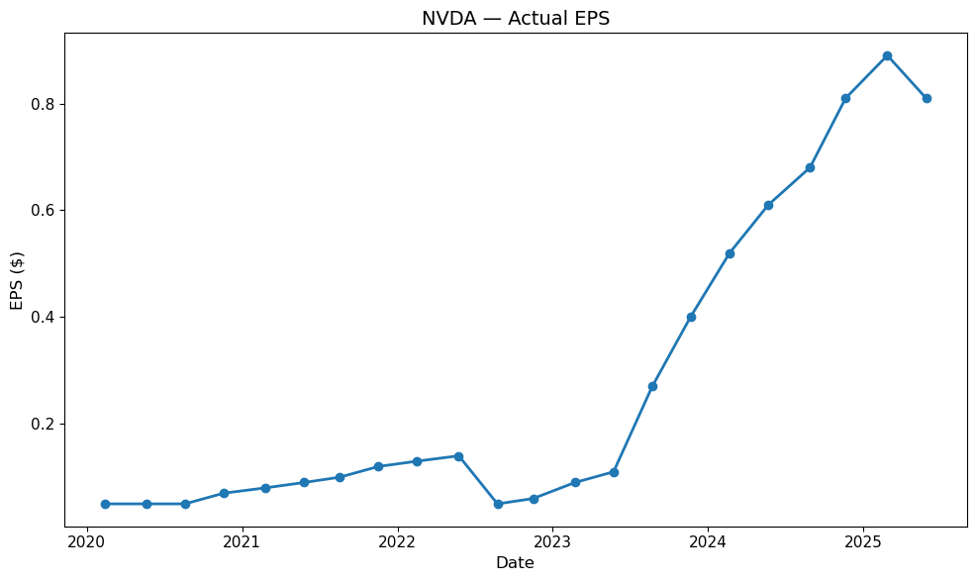
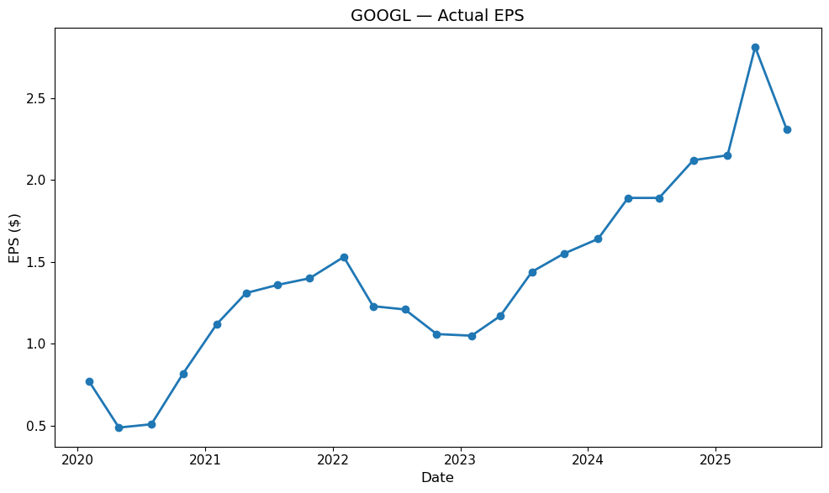
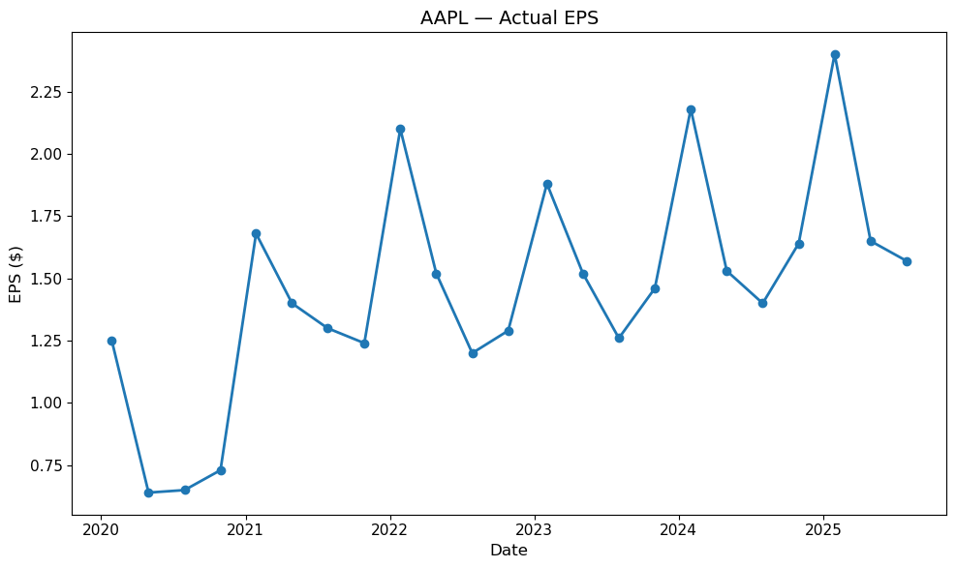

Figure 1 – 3
Actual EPS results since 2020.

APPL: The chart shows a strong seasonal trend in results announced, coinciding with the Christmas boom in sales. It is clear to see the impact on EPS from the global pandemic in 2020.

GOOGL: EPS shows a steady consistent growth trajectory over the years, with only small dips. Recent quarters hit new highs following development of Google’s AI ‘Gemini’

NVDA: EPS growth is exponential, especially from 2023 onwards.

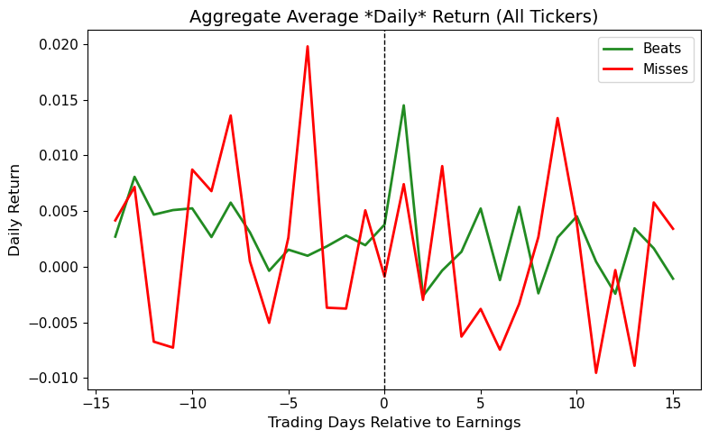
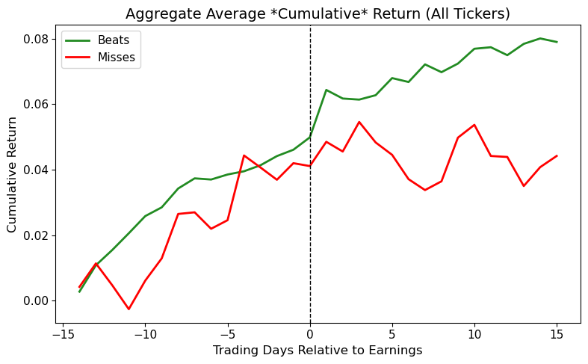
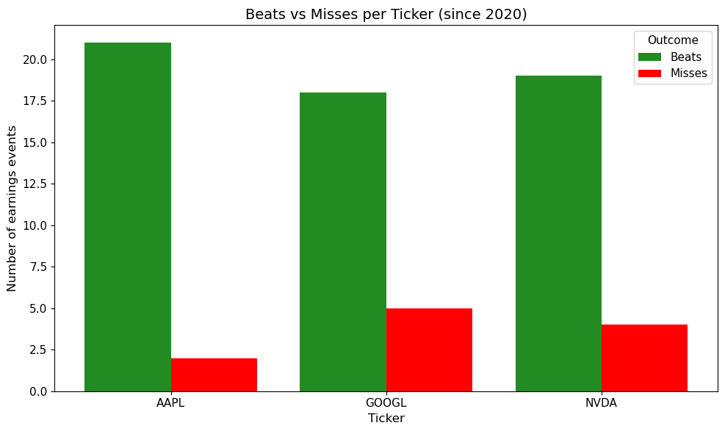
Beats v Misses and Event Windows
Figure 4 – 6
Beats v Misses. Event window returns.

(Left) – All three tickers have delivered earnings beats far more often than misses.

(Bottom left) – Stocks that beat EPS estimates show a strong, sustained positive drift in cumulative returns both before and after earnings. Misses still show some pre-earnings run-up, but performance flattens, or lags post announcement compared to beats.

(Bottom right) – Daily volatility is higher for misses, with sharper swings around the announcement date. Beats show steadier daily returns, though still with small positive spikes around earnings.

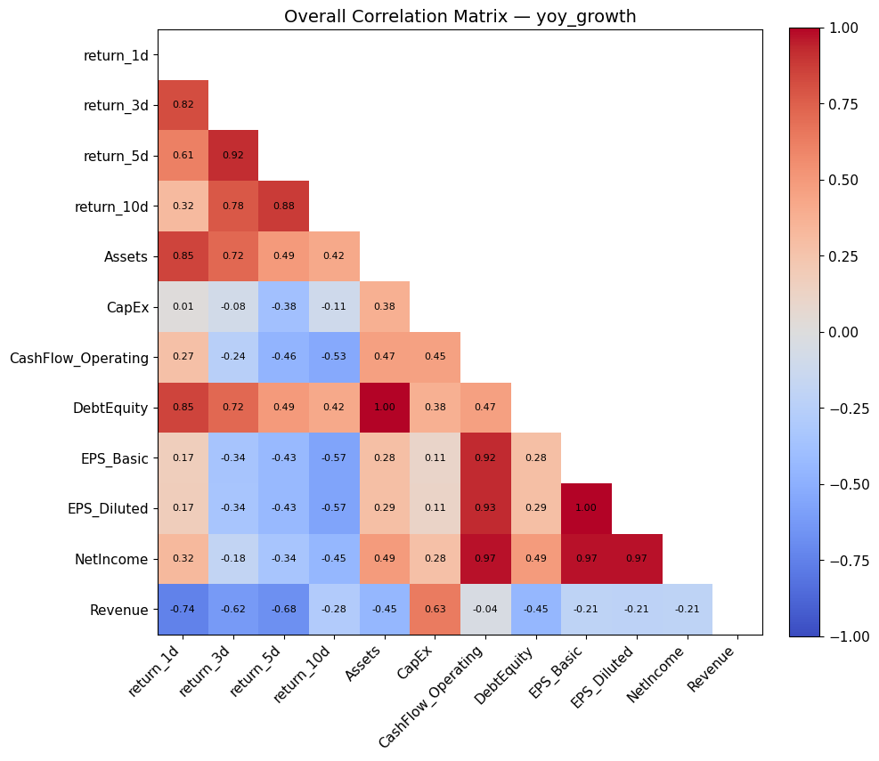
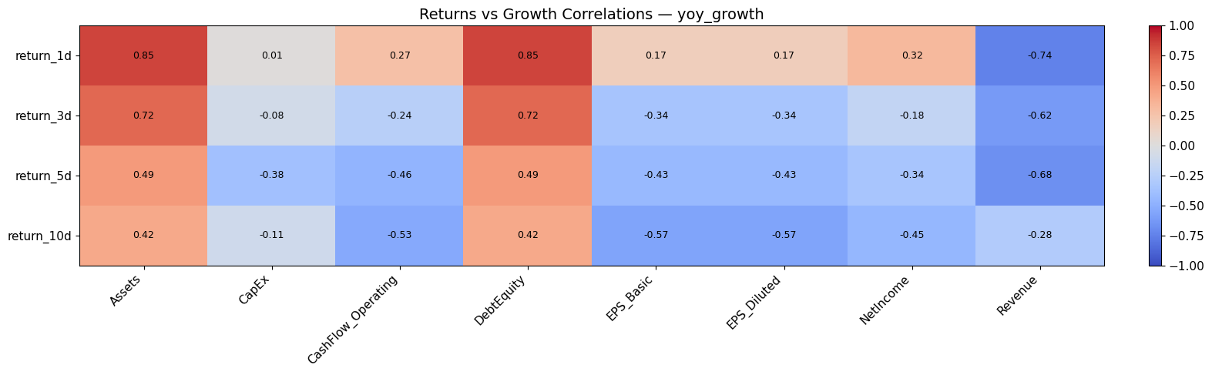
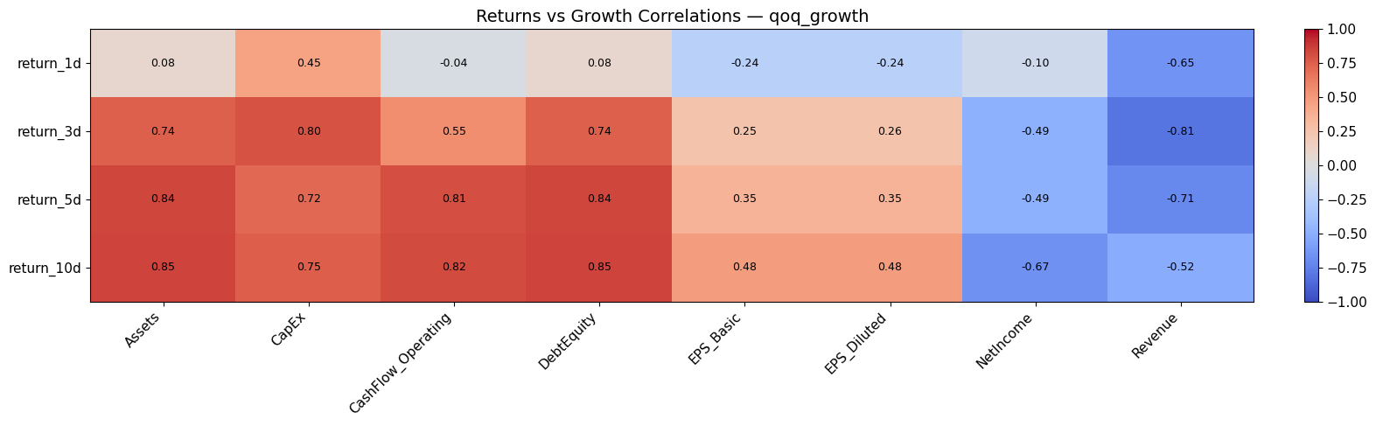
Growth in concepts vs. return
Figures 7-10

Top – Short term returns correlate positively with CapEx and Debt/Equity suggesting markets reward higher investment activity or leverage. Strong negative correlations with Revenue and Net Income, which is counter intuitive.

Middle – One day returns are positively linked with Assets and Debt/Equity but negatively with Revenue growth

Bottom – Returns are tightly correlated across horizons (e.g. 1d v 3d: 0.82). Revenue growth is consistently negatively correlated with returns and other fundamentals, possibly suggesting revenue expansion comes at the expense of profitability.

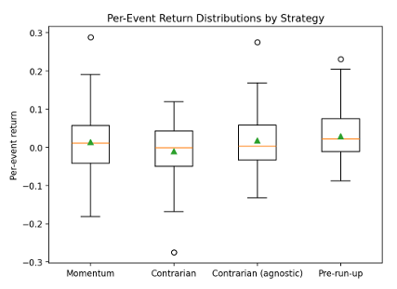
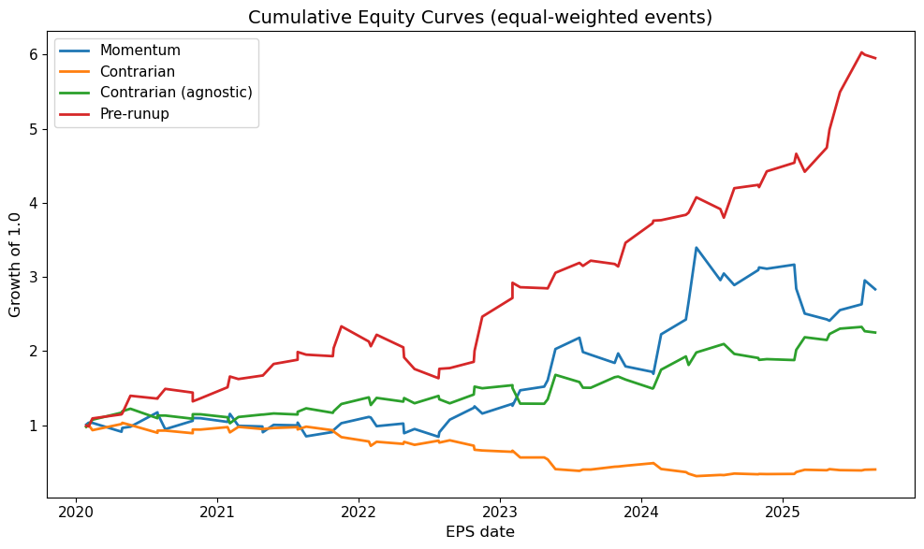
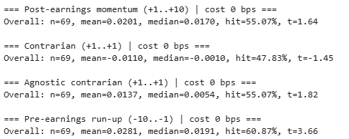
Trading Strategies
Figures 10 – 12

(Left) – Summary statistics.
Pre-earnings run-up: strongest mean return (2.81%), high hit rate (~61%), highly significant (t =3.66). Momentum: modest positive mean (2.01%), decent hit rate (55%) but only mildly significant.
(Bottom Left) – Return distributions boxplot
Pre-run has the most positively skewed distribution, with stronger average and median returns.
(Bottom Right) – Cumulative equity curves
Pre-run dominates, compounding steadily to ~6x growth by 2025.

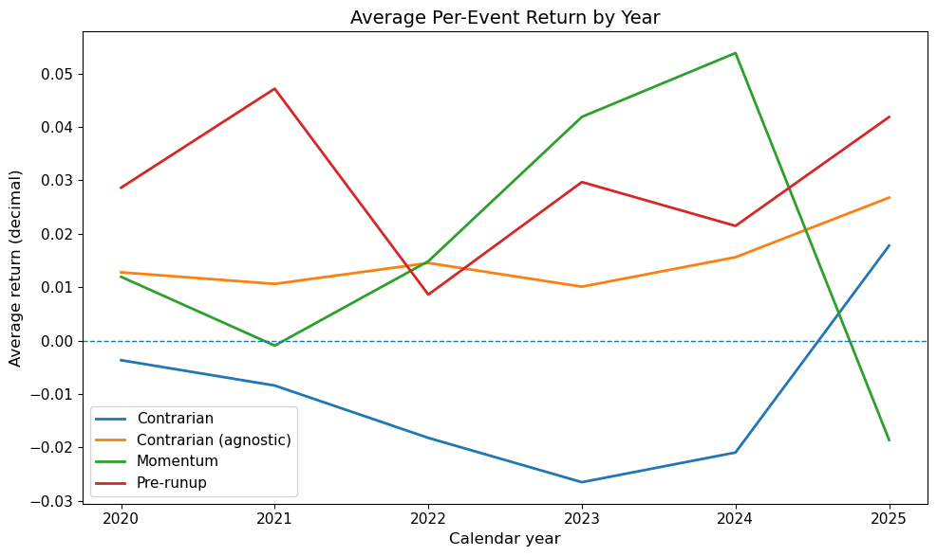
Average return by year
Figure 13

(Left) – Average per event returns by year

Momentum: shows clear upward trend from 2021 to 2024, before falling sharply in 2025.

Pre-run up: consistently positively and more stable than momentum

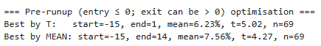
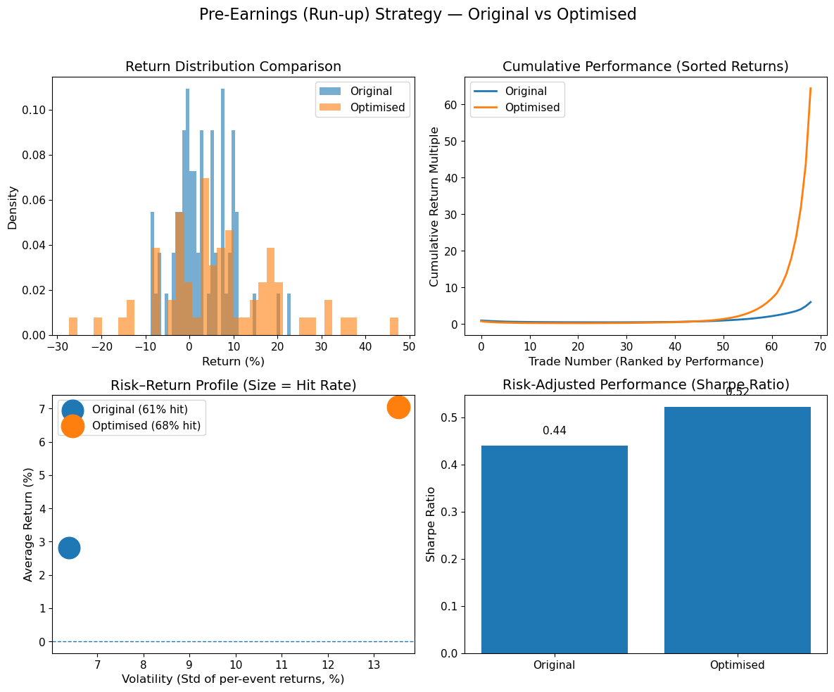
Optimised Pre Run Up Strategy
(Left)
Figure 14
Optimised summary statistics

(Bottom Left):
Figure 15
Original v Optimised
The optimised pre-run strategy delivers stronger returns, higher hit rates and better risk-adjusted performance, albeit with more volatility.

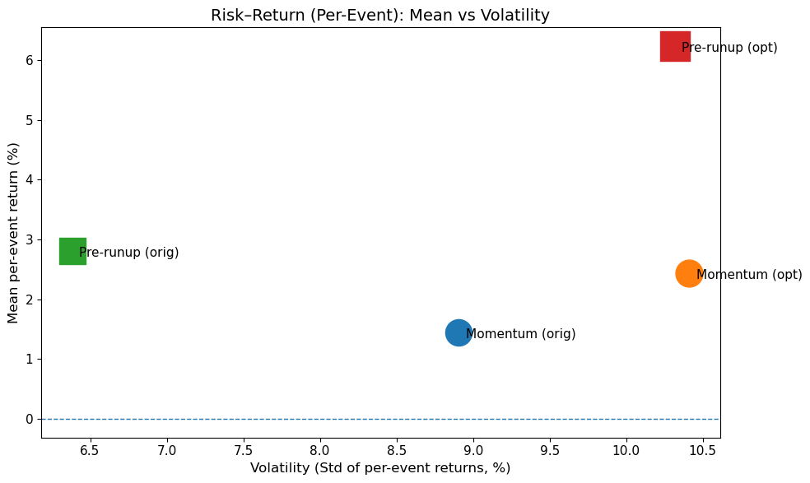
Risk-Return: Mean v Volatility
Figure 16:

Risk v Return

Pre-run up (optimised, red): stands out as the clear winner – highest mean per event return (~6.2%) but at the cost of higher volatility (~10.5%). Strong risk-reward tradeoff.

Pre-run up (original, green): Much lower volatility (~6.4%) and more modest returns (~2.8%). A safer but less profitable approach.

Momentum (blue/orange): Both versions sit close together around 2% mean return with ~10.3% volatility. Optimisation gives a small lift in returns with extra extra risk.

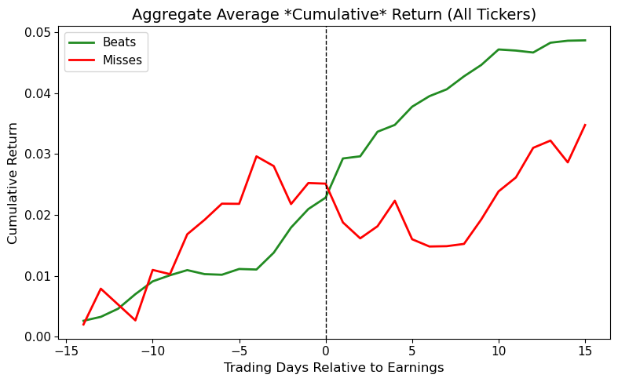
Insights - Top 19 NASDAQ Stocks
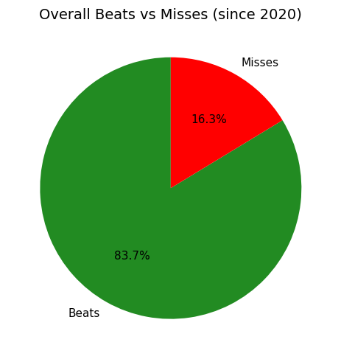

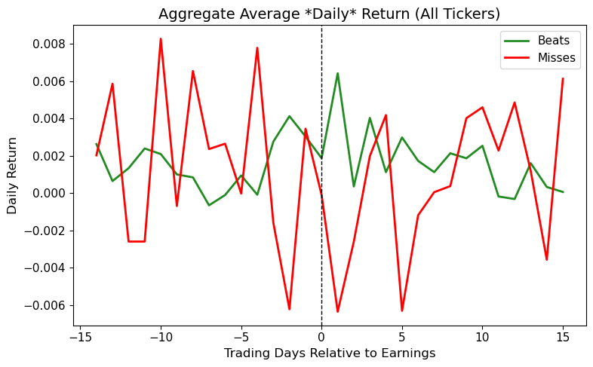
Figures 17 – 20
Overall beats v misses
Very strong positive skew, confirms view that large cap NASDAW stocks generally outperform analyst expectations.

Cumulative returns (top right)
Beats show a steady upward drift post earnings. Misses initially see a run-up before results, but underperform after earnings.

Daily returns (bottom right)
Misses exhibit much higher volatility, beats are more consistent.

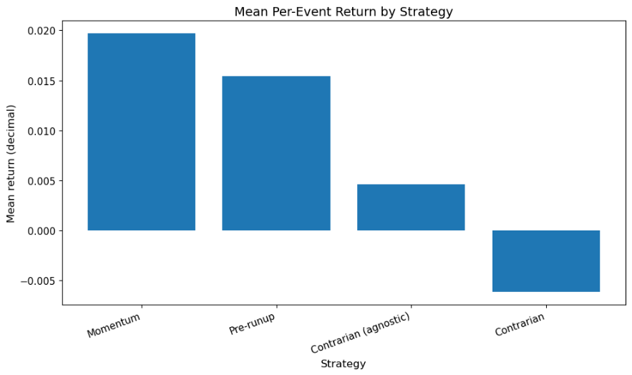
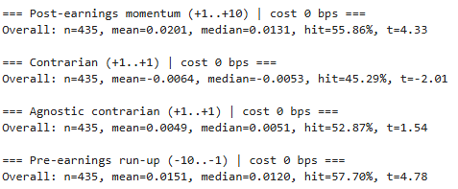
Trading Strategies (19 Stocks)
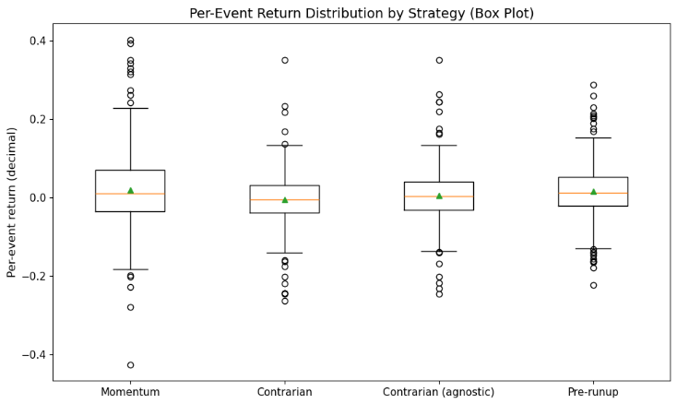
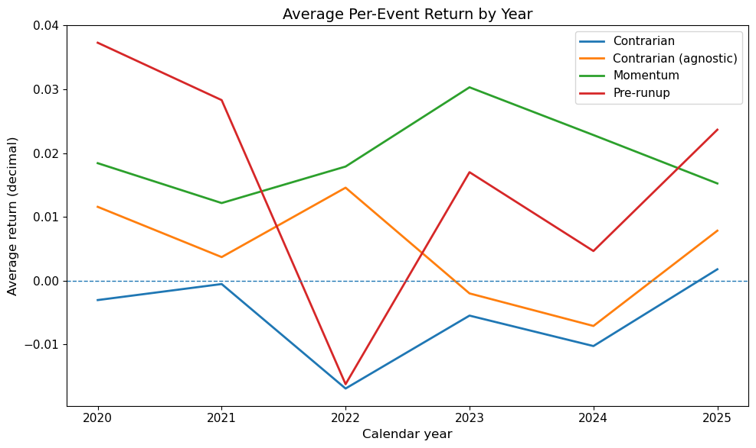
Figure 21-25
Momentum the strongest performer overall, mean ~2%, hit rate 56%, highly significant (t=4.33). Momentum and pre-run up have higher medians and more positive skew delivering positive performance in most years, though pre-run dipped sharply in 2021, most likely due to higher inflation and rising rates.

Figure 10 – Summary statistics
Figure 14 – Optimised summary statistics
Figure 21 – NASDAQ 19: Summary statistics

